Ayush Goyal 190905522
CSE D 62
Distributed Systems Week 1: Lab 1: Python Basic Practice-I

1. Assigning Values to Variables

counter = 100 # An integer assignment
miles = 1000.0 # A floating point
name = "John" # A string
print (counter)
print (miles)
print (name)

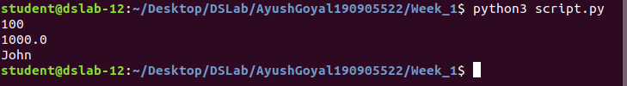

2. Multiple Assignment

Python allows you to assign a single value to several variables simultaneously.
For example:
a = b = c = 1
print(a,b,c)
a, b, c = 1, 2, "john"
print(a,b,c)

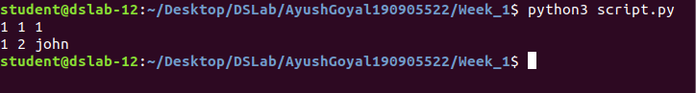

3. Standard Data Types

Python has five standard data types:
Numbers
String
List
Tuple
Dictionary

4. Python Numbers

a = 5 # integer assignment
b= 4.56 #floating point assignment
#mathematical operations with scalar variables
print (5*a) #would give the result 25
print (a/2) #would give the result 2.5
print(a**2) #is the power (squaring operation) would give the result 25
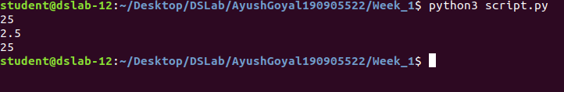
5. import numpy as np

numpy includes various scientific functions like log10, log2, natural log, exp, floor, ceil, rounding and all statistical summary functions.

6. Python Strings

str = 'Hello World!'
print (str) # Prints complete string
print (str[0]) # Prints first character of the string
print (str[2:5]) # Prints characters starting from 3rd to 5th
print (str[2:]) # Prints string starting from 3rd character
print (str * 2) # Prints string two times
print (str + "TEST") # Prints concatenated string

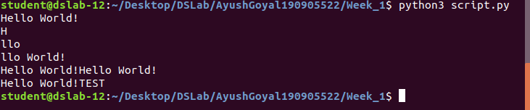
7. Updating a string

var1 = 'Hello World!'
print ("Updated String :", var1[:6] + 'Python')

Ans: Updated String :Hello Python

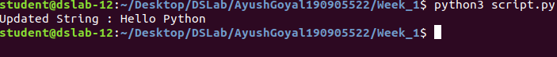
8. String formatting operator

One of Python's coolest features is the string format operator %. This operator is unique to strings and makes up for the pack of having functions from C's printf() family. Following is a simple example:

print( "My name is %s and weight is %d kg!" % ('Anitha', 55))
My name is Anitha and weight is 55 kg!

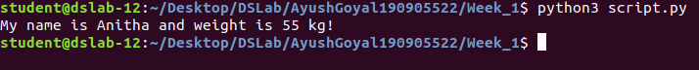
9. Built-in String methods

capitalize() , the first character of the string is converted to upper case.

str = "this is string example....wow!!!";
print (str.capitalize())

Ans: This is string example....wow!!!

count(), counts the number of times a specific substring, occurrence in the main string

str = "this is string example....wow!!!";
print(str.count('s'))

Ans: 3 # three timess, appears in str.

find() , will locate the position of searching substring, (index)

print(str.find('example'))

Ans: 15 #at 15th index, the substring ‘example’ is placed.

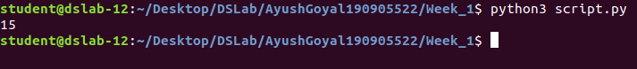
lower(), returns a copy of the string in which all case-based characters have been lowercased.

str = "THIS IS STRING EXAMPLE....WOW!!!";
print (str.lower())

this is string example....wow!!!

replace(), this method returns a copy of the string with all occurrences of substring old replaced by new.

str = "this is string example....wow!!! this is really string";
print (str.replace("is", "was"))

Ans: thwas was string example....wow!!! thwas was really string

swapcase(), this method returns a copy of the string in which all the case-based characters have had their case swapped.

str = "this is string example....wow!!!";
print (str.swapcase())

Ans: THIS IS STRING EXAMPLE....WOW!!!"

title(), returns a copy of the string in which first characters of all the words are capitalized.

str = "this is string example....wow!!!";
print (str.title())

Ans: This Is String Example....Wow!!!

10. Python LIST

Lists are the most versatile of Python's compound data types. A list contains items separated by commas and enclosed within square brackets ([]). To some extent, lists are similar to arrays in C. One difference between them is that all the items belonging to a list can be of different data type.

The values stored in a list can be accessed using the slice operator ([ ] and [:]) with indexes starting at 0 in the beginning of the list and working their way to end -1. The plus (+) sign is the list concatenation operator, and the asterisk (*) is the repetition operator. For example:

list = [ 'abcd', 786 , 2.23, 'john', 70.2 ]
tinylist = [123, 'john']
print (list) # Prints complete list
print (list[0]) # Prints first element of the list
print (list[1:3]) # Prints elements starting from 2nd till 3rd
print (list[2:]) # Prints elements starting from 3rd element
print (tinylist * 2) # Prints list two times
print (list + tinylist) # Prints concatenated lists

Output will be like this

['abcd', 786, 2.23, 'john', 70.200000000000003]
abcd
[786, 2.23]
[2.23, 'john', 70.200000000000003]
[123, 'john', 123, 'john']

['abcd', 786, 2.23, 'john', 70.200000000000003, 123, 'john']

Note: LIST is mutable data type

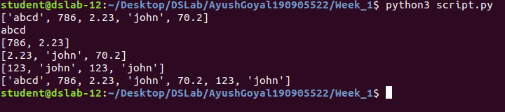

11. Functions & Methods in LIST

list = ['physics', 'chemistry', 1997, 2000];
list.append('maths')
print(list)

Ans: ['physics', 'chemistry', 1997, 2000, 'maths'];

To delete an element in a list

del list[2] #will remove 1997 record from the list.
print(list)

To check a data in a list,
'physics' in list #will return 'True'
'english' in list #will return 'False'
len(list) #will return total items in list
list.count('physics')

Ans: 1
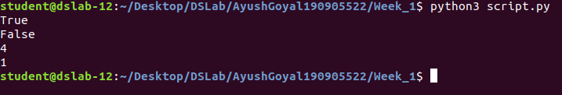
list.pop () #will remove and return the last item from the list.

list = ['physics', 'chemistry', 1997, 2000];
list.pop()
print(list)

Ans: ['physics', 'chemistry', 1997]l

ist.insert() #will insert an item in the specified index

list = ['physics', 'chemistry', 1997, 2000];
list.insert (2, 'maths')
print(list)

Ans: ['physics', 'chemistry', 'maths', 1997, 2000];

list = ['physics', 'chemistry', 1997, 2000];
list.remove('chemistry') #will remove the item specified.
print(list)

Ans: = ['physics', 1997, 2000];

list = ['physics', 'chemistry', 1997, 2000];
list.reverse() #will reverse the objects of the list in place.
print(list)

Ans: [2000, 1997, 'chemistry','physics']

12. Python TUPLE

A tuple is another sequence data type that is similar to the list. A tuple consists of a number of values separated by commas. Unlike lists, however, tuples are enclosed within parentheses.
The main differences between lists and tuples are: Lists are enclosed in brackets ( [ ] ) and their elements and size can be changed, while tuples are enclosed in parentheses ( ( ) ) and cannot be updated. Tuples can be thought of as read-only lists.

tuple = ( 'abcd', 786 , 2.23, 'john', 70.2 )
list = [ 'abcd', 786 , 2.23, 'john', 70.2 ]
print(tuple)
print(list)
tuple[2] = 1000 # Invalid syntax with tuple
list[2] = 1000 # Valid syntax with list

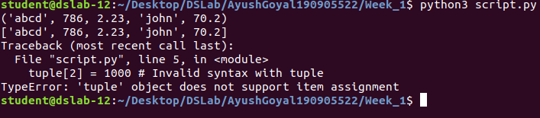

13. Looping & Conditional Branches in Python

Eg.1

num=float(input('Enter a number:'))
if num>0:
print('pos number')
elif num==0:
print('zero')
else:
print('Neg number')

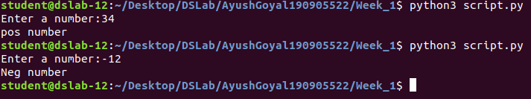
Eg.2

x=float(input('Enter a number:'))
if x<10:
print('smaller')
if x>20:
print('bigger')
print('Finished')

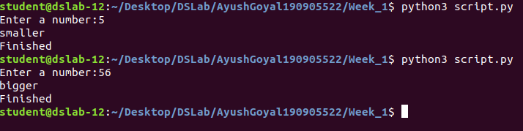
Eg.3

x=5
print('Before 5')
if x==5:
print ('this is 5')
print('still 5')
print('After 5')
print('Before 6')
if x==6:
print('this is 6')
print('After 6')

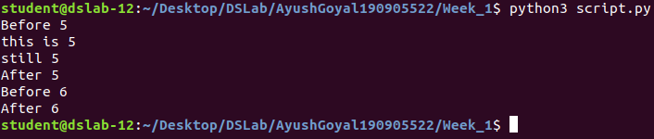
Eg.4: which will never print?

x=float(input('Enter a number:'))
if x<20:
print('Below 20')
elif x<10:
print('Below 10')
else:
print('something else')

Ans: Below 10

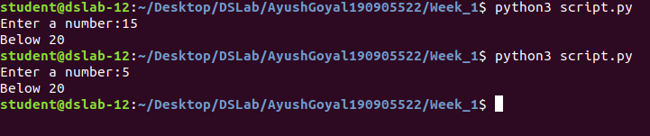
Eg.5: Nested Decisions

x=42
if x>1:
print('above one')
if x<100:
print('less than 100')
print('All done')

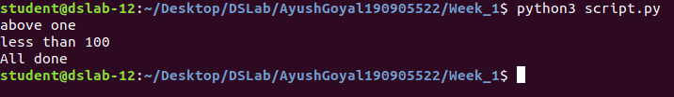
Eg.6: Ternary operator

age=15
b=('kid' if age<18 else 'adult')
print(b) #this will print 'kid'

14. Usage of For-loop

Eg.1

for val in [5,4,3,2,1]:
print(val)
print ('Done')

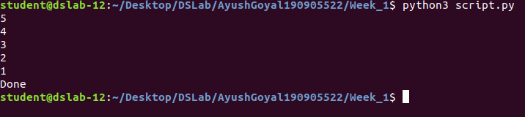

Eg.2

stud=['Ram','Vijay','Nithya','Anu','Ramesh','suja']
for k in stud:
print('Hello:', k)
print('done')
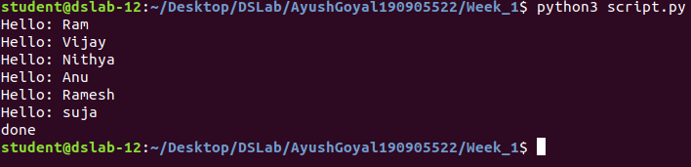

Eg.3

for i in range(5):
print(i)
if i>2:
print('Bigger than 2')
print('Done with i',i)

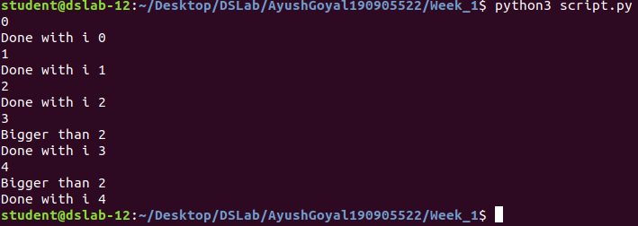

Eg.4: Calculate factors of a number

x=int(input('Enter a number:'))
for i in range(1,x+1):
if x%i ==0:
print(i)
x=10
1,2,5,10

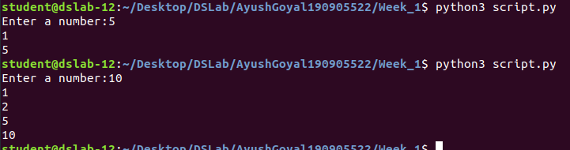
Eg.5: Calculate largest number in an array

from math import *
x= [9, 41, 12, 3, 74, 15]
Largest=-inf
for i in x:
if i>Largest:
Largest=i
print(Largest)

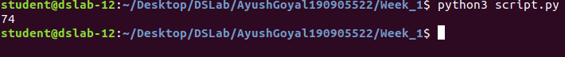
Eg.6: Calculate smallest number in an array

from math import *
x= [9, 41, 12, 3, 74, 15]
smallest=inf
for i in x:
if i<smallest:
smallest=i
print(smallest)

Eg.7: Calculate the count, sum and average of numerical array

x = [9, 41, 12, 3, 74, 15]
count=sum=avg=0
for i in x:
count=count+1
sum=sum+1
avg=sum/count
print(count)
print(sum)
print(avg)

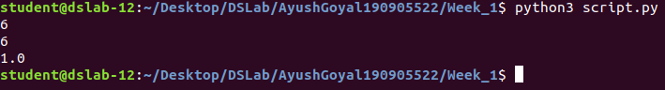
Eg.8: Filtering in a loop (print all numbers >20)

x = [9, 41, 12, 3, 74, 15]
for i in x:
if i>20:
print (i)
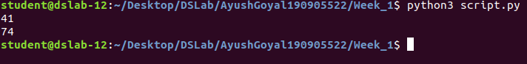

Eg.9: For the above problem, instead of printing the result, store the elements in a variable (object)

x = [9, 41, 12, 3, 74, 15]
res=[]
for i in x:
if i>20:
res.append(i)
print(res)

Eg.10: For the above x, replace all elements <20 into zero. Store the result in different variable (object)

y=np.zeros(len(x))
for i in range(len(x)):
if x[i]>20:
y[i]=x[i]
print(y)

THE END

